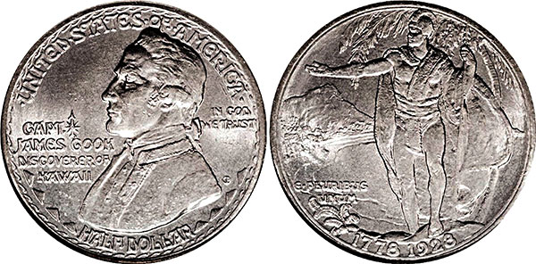
A rare Capt. Cook half dollar.
IMAGE: SANDY WATANABE

Dollars and sense
Owner of Captain Cook Coin Co. on treasure hunting
INTERVIEW BY SHANTEL GRACE | OCT 13, 2010 |
CRAIG WATANABE / Like many of the old-time coin dealers, Craig Watanabe, owner of Captain Cook Coin Co., believes that treasure hunting is the nature of a true collector’s being. He’s a wholesaler most of the time, but on rare occasions, Watanabe retails his coins at trade shows, collectible shows and conventions. He hopes that someday the coins will make their way back to him.
Some of his most precious coins include historical currency, rare tokens and medals, Civil War coins and love tokens. He has more than five decades of numismatic (the science of coins and medals) experience, and it all began after a fortunate family outing nearly 60 years ago.

How exactly did you become a coin collector?
My dad was a freelance commercial artist who had to work 10-plus hours a day, six, sometimes seven days a week. He was one of the original artists with Marvel comics and we hardly did anything together. So one special day, when I was 9, he took us, as a family, to a nice dinner. And afterwards he took us to a brand new coin shop that had opened in our neighborhood. We looked through a bowl of Indian-head cents they made stacks of each year, and then we picked out the best from each stack. They were 10 for a dollar. When I got home, I held these coins from 1880-1907 and imagined who may have touched them. From there I was hooked. Thankfully the coin shop owner liked kids and almost every day after school there would be a bunch of us in his shop looking for new coins we could afford to buy and oohing and aahing at the ones we couldn’t.
What are some of the strangest coins to come into your store?
Among the strangest are the counterfeits that are getting better and better, coming in from Asia through the Internet. In the past there’ve been many fantasy pieces that are made to depict a thought. But sometimes they’re a little weird or x-rated.
Do you have coins from shipwrecks?
I’ve handled them in the past, but the amazing ones are the valuable gold ones that have been virtually restored to their original uncirculated conditions through the modern science of chemistry and electrolysis and technology of underwater deep sea salvaging.
What is the oldest coin you have or had at one time?
Right now I have a nice inventory of Widow’s Mites. These are around 2,000 years old and are biblically referenced in parable. I like these because they are relatively inexpensive and very historical.
Have you ever regretted selling a coin?
There’ve been many, but I’ve learned that you can’t fall in love with your inventory. A good thing though, if you sell such coin, is that it keeps regular customers coming back. About 25 years ago, the late actor Buddy Ebsen sold his coin collection at auction, and when asked why he was selling his collection, he said something like, “I believe we are keepers of these things only for a short time. At my age it’s time to let them go and let someone else enjoy them for awhile.”
Why do you think people collect coins?
One good thing about being active through multiple generations of coin collectors is living through the evolution. Long ago, almost all collectors did so for the love of the hobby. They weren’t really that interested in how much money a coin was worth, but more in achieving completion of a set or the thrill of the hunt. Sadly, nowadays, it seems like everyone, including the younger dealers, are only interested in how much money a coin is worth. Although good for reassurance, certified coins have taken away a lot of the need for coin knowledge. Today, coins are mostly used as an investment vehicle. Unfortunately, the value of many coins has risen to a level where the average wage earner has been priced out of the market.
What is the best clue when separating the fakes from the authentic coins?
Education. The American Numismatic Association has an excellent home CD course on counterfeit coins. There are many telltale characteristics and they’re getting better all the time. An active numismatist needs to keep learning about new fakes. I have some very loyal customers dating back 30-40 years. Our knowledge span is only as wide as our education.
Do you consider yourself a treasure hunter?
I believe that is the nature of a true collector’s being. Like many of the old-time dealers, that is how I started and still am. I’m just blessed that it has turned out to be my vocation.
[CaptainCookCoin.com], [email: captaincookcoin
http://honoluluweekly.com/qanda/2010/10/dollars-and-sense/

